Sales

Customer

Sales by Customer

Target

9.87

Sales by Location



0 50 100 150 200 250 300 350

Abeokuta

Abuja

Calabar

Ibadan

Ilorin

Kaduna

Kano

Lagos

Port Harcourt

Warri

Location

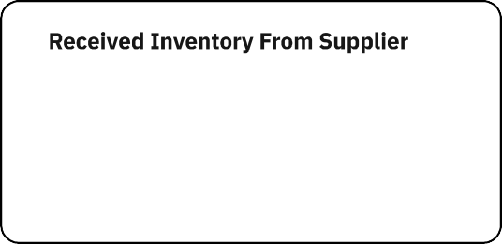

Sales by Sales Rep

Inventory Stock for Warehouse Locations

0 10,000 20,000 30,000 40,000 50,000 60,000 70,000 80,000 90,000

Monthly

Sales Trend

8.57

Monthly Sales

9.196

Pleasures @ Actual

Actual and Received Inventory by Plonth

@ Received Inventory



April August Decembei February 3aisuary July J « e March May NovemlJer Octobei SeptemlJer